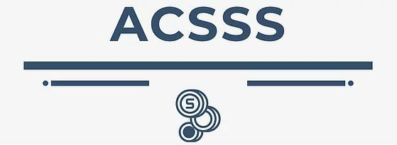

ACSSS Board Meeting

March 25, 2024, at 2:00 p.m. Eastern

Microsoft Teams meeting

CONFIDENTIAL - FOR ACSSS BOARD MEMBERS ONLY

|  |  |  |
| --- | --- | --- |
|  | **Agenda Topic** | **Presenter** |
| 1. | Call to Order and attendance | Kevin Allard |
| 2. | Member Terms and renewals (Document for your review) | Mary Beth Quist |
| 3. | 4Q 2023 Financial Report (supporting documents)   * Member Dues Discussion | Jeff Morris |
| 4. | Community Banker Sentiment Index and Economic Update  Q4 2023 CBSI: <https://www.csbs.org/cbindex> Key Highlights:  * **A score of 92 represents the highest reading from the index in nearly two years**. The fourth quarter uptick follows last quarter’s increase of 13 points, making the six-month increase of 19 points the highest recorded since the survey premiered in 2019. * While the fourth quarter 2023 CBSI is the eighth consecutive reading below the neutral level of 100,**it marks the first consecutive quarterly increases since early 2021**. * Five of the seven components that comprise the CBSI improved from the previous quarterly survey. The indicators that **dropped**include **capital spending** (down 14 points) and **operations expansion** (down 10 points). * At 96, **the monetary policy component had the greatest quarterly improvement**, climbing 42 points from Q3 2023 and near the neutral level of 100. * At 73, the business conditions component rose 14 points. **This level still indicates a weaker economic outlook, but one that is not as bleak as previously indicated**. Like the overall index, the business conditions component has been below 100 for eight consecutive quarters but is at its highest level since Q1 2022. * In a special question, 81% of community bankers believe the U.S. economy is at the start of, or already in, a recession. The percentage is down from 87% last quarter. |  |
| 5. | Financial & Banking Information Infrastructure Committee (FBIIC) Report | Mary Beth Quist  Kevin Allard  Jonathan Finley |
| 6. | Federal Financial Institutions Examination Council (FFIEC) Report   * April SLC Briefing and Council Meeting * Current Projects and Priorities of Note | Mary Beth Quist  Kevin Allard |
| 7. | Roundtable | All |
|  | | |